**Course Offering: Enroll for Spring 2024**

CHEM 259: Selected Topics in Biological Chemistry

**“Stimuli-Responsive Materials for Biomedical Applications”**

|  |  |
| --- | --- |
| **Instructor**: Prof. Andrea S. Carlini  **Time:** MW 2:00-3:15pm  **Location**: GIRV 1106 | **Enrollment Code:** 06486*  **Prerequisites**: consent of instructor |

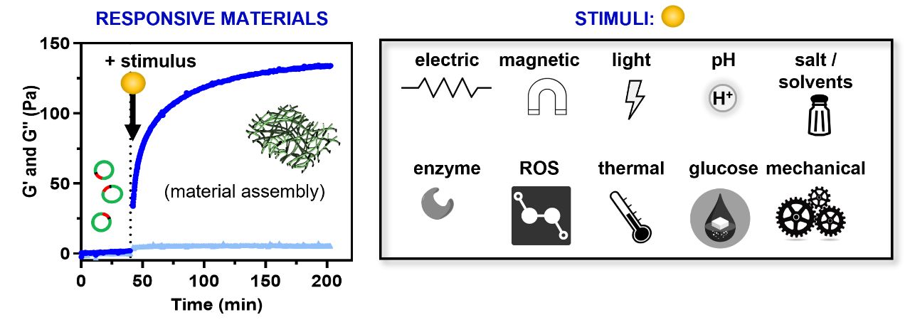

**Course Description**

Stimuli-responsive chemistries and materials are programmed to react in the presence of changes in their surrounding environment to produce a measurable output, such as a change in shape, release of active moiety, assembly, or mechanical output. Examples of stimuli can include electric field, magnetic, thermal, light,** mechanical, pH, ROS, enzyme, glucose, and others (e.g. salts, solvents, electron beam). We will discuss the properties, design, and applications of these stimuli-responsive materials that have aided the development of active-, as opposed to passive, biomaterials for the advancement of biomedicine. This course makes use of modern scientific literature to discuss the topics at hand.

*Chem 259 is the same course as BMSE 259. This course may be repeated with a different topic (18 units maximum). Selected topics from bio-organic, biophysical, or biological chemistry. The content of this course will vary. Please contact Undergraduate Advising if you run into issues registering for this course.

**Topics related to light-responsive materials are covered in other electives and will only be discussed briefly in this lecture.